A
Report

On

Students’ Seminar
Session- 2023-24

Department of Philosophy
Rabindra Mahavidyalaya, Champadanga

Theme:
বিবেকানন্দ-এর সমাজ দার্শনিক চিন্তন
Venue: Department of Philosophy
R.N. 68
Date: April 2nd, 2024
Organizer: Department of Philosophy
Paper Presenters: Students of Semester IV & VI (Hons.)
Audience: Students of Semester IV and VI (Hons.)
Objectives :
- Learn a systematic study of ideas and issues;
- Pursuit of fundamental truths, a quest for a comprehensive understanding of the world, a study of principles of conduct and much more.
• Development of Discussion skills, exhibit independence and flexibility of thought, and time management;
- Stimulate listening skills, argumentative skills and critical thinking;

Proceedings
The seminar, hosted by Prof. SuklaSaha, began with the introductory speech given by Prof. Soumitra Das, Assistant Professor of Department of Philosophy of the institution. All three technical sessions were chaired by the departmental faculties. Prof. Sourish Dey and Prof. Sima Choudhury acted as judges. Prof. SanchitaKheto monitored the whole session. There were three groups of paper presenters, each group containing not less than three students. All sessions were very interactive where pupils have been quite enthusiastic, and all of their questions have been satisfactorily answered. 60 students (Male: 12, Female: 48) participated in the seminar. The seminar ended with vote of thanks by Prof. Soumitra Das.

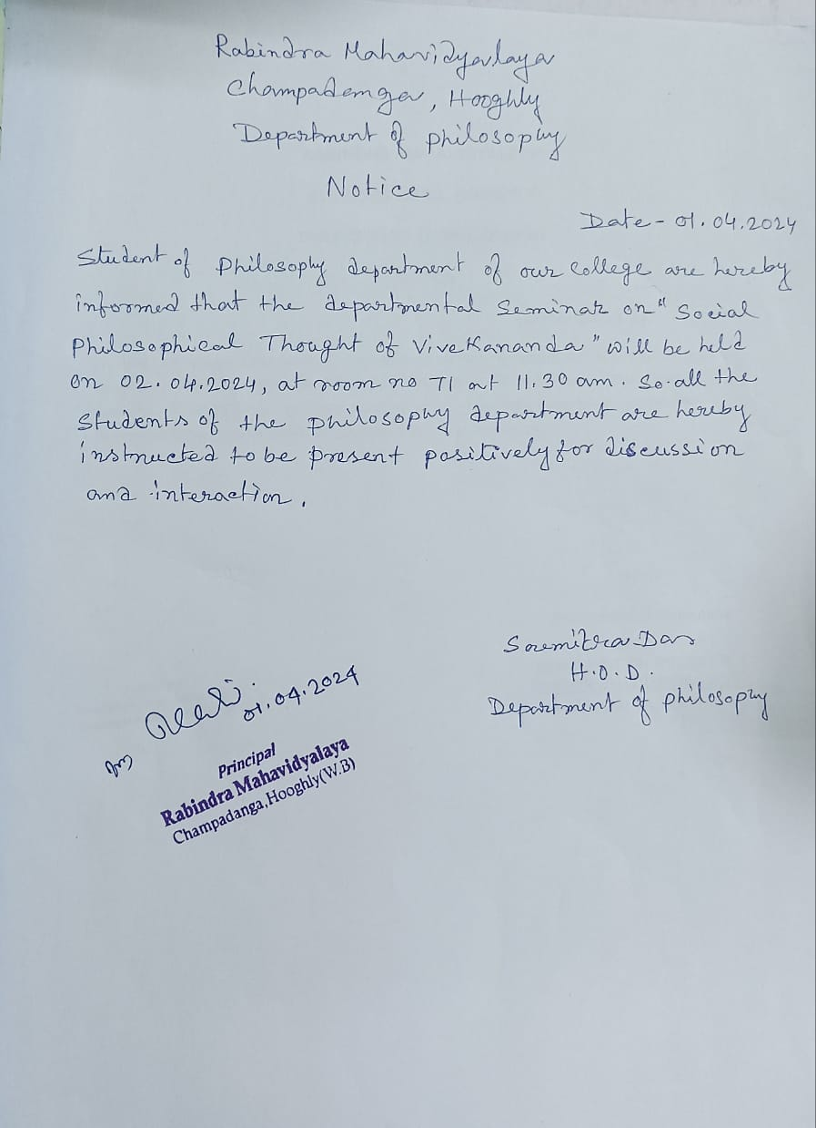

Student’s Seminar
Theme: বিবেকানন্দ-এর সমাজ দার্শনিক চিন্তন
Date: 02.04.2024
Venue: Department of Philosophy, Rabindra Mahavidyalaya, Champadanga
Time: 10 a.m. to 1 p.m.

- Inauguration
- Principal’s Speech
- Technical Session 1: 10.30 a.m. to 11.15 a.m.

- Chairman: Soumitra Das
- Rapporteur: SanchitaKheto
- Paper: বিবেকানন্দের ফলিত বেদান্তের ধারণা
- Tiffin Break

- Technical Session 2: 11.30 a.m. to 12.15 p.m.

- Chairman: Sourish Dey
- Rapporteur: Soumitra Das
- Paper: বর্তমান সমাজ ও স্বামী বিবেকানন্দ

- Technical Session 3: 12.20 p.m. to 1.05 p.m.

- Chairman: SanchitaKheto
- Rapporteur: Sima Choudhury
- Paper: সমাজ ও দর্শন বিষয়ে বিবেকানন্দের ধারণা
- Prize Distribution

- Vote of Thanks: Prof. Soumitra Das

Student’s Seminar

List of Participants

Theme: স্বামী বিবেকানন্দ-এর সমাজ দার্শনিক চিন্তন
Date: 02.04.2024
Venue: Department of Philosophy, Rabindra Mahavidyalaya, Champadanga
Time: 10 a.m. to 1 p.m.

- Paper: বিবেকানন্দের ফলিত বেদান্তের ধারণা

- Presenters: Tripti Adhikari, Rupsa Jana, Rima Sasmal& Jhumpa Adhikari.

Paper Presented by Tripti Adhikari.

- Paper: বর্তমান সমাজ ও স্বামী বিবেকানন্দ

- Presenters: Shrabani Ghosh, Sarbojit Patra, SupriyaPorel&RadhasriPanja .

Paper Presented by Shrabani Ghosh.

- Paper :সমাজ ও দর্শন বিষয়ে বিবেকানন্দের ধারণা

- Presenters: BacchuMohanto, Sutapajana, Nisha Manna &SayaniBasu .

Paper Presented by BacchuMohanto.

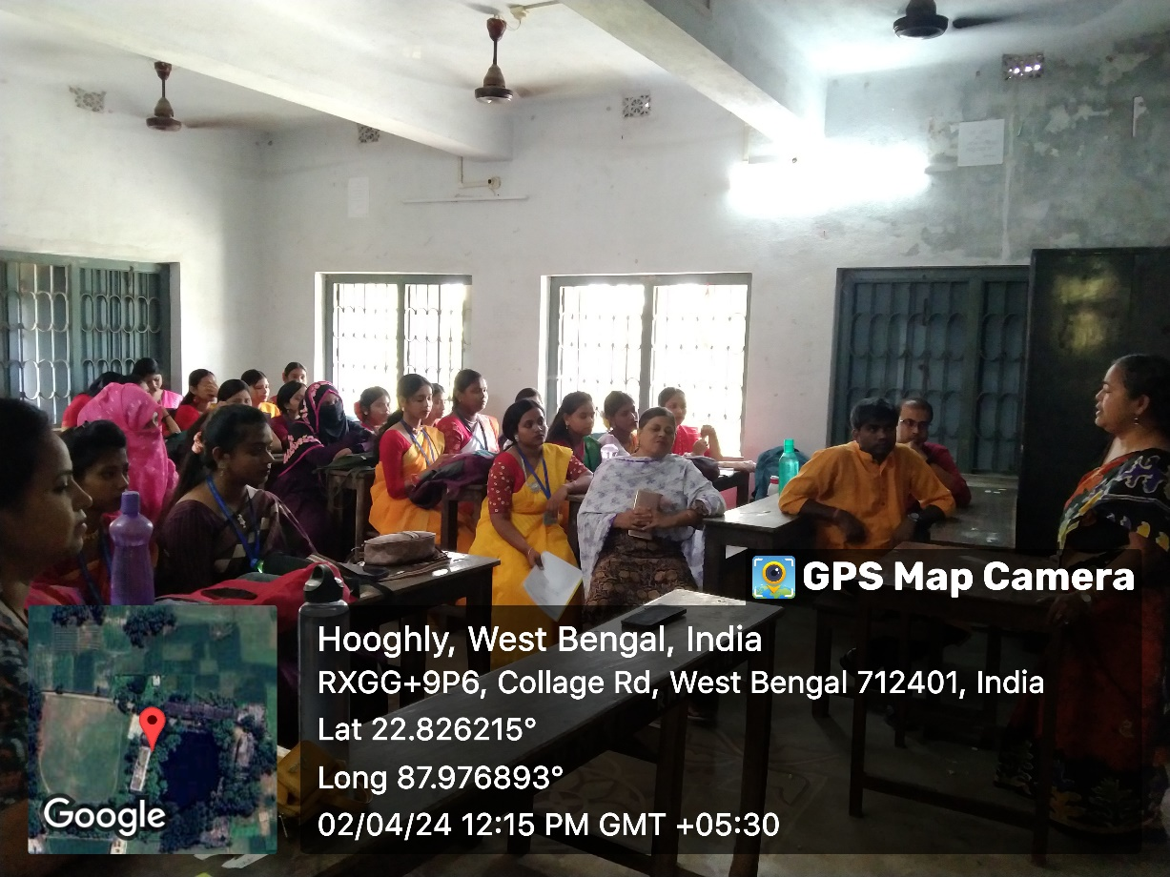
The seminar, hosted by Prof. SuklaSaha
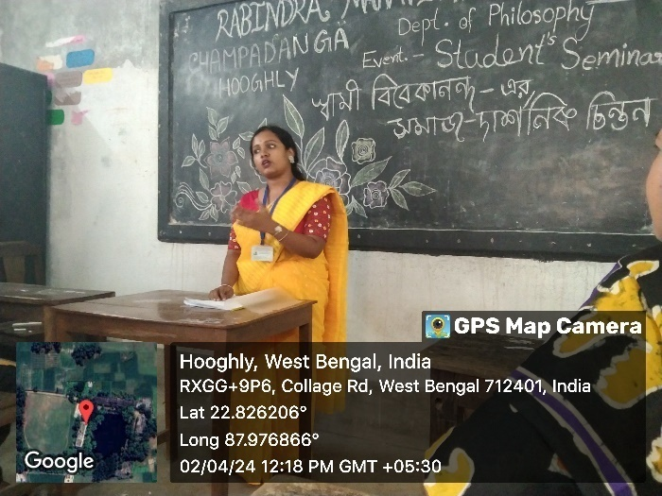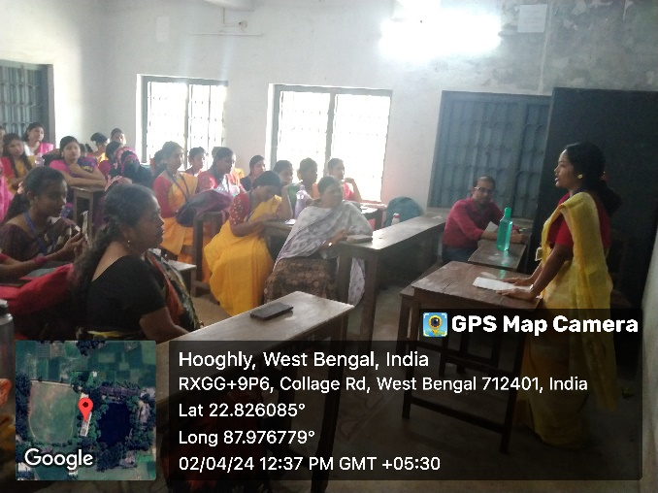
Paper presented by students
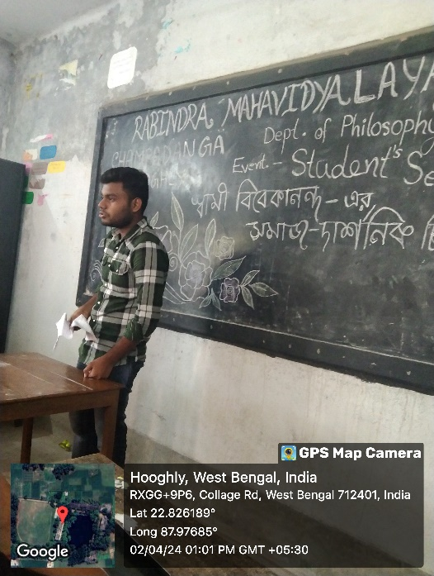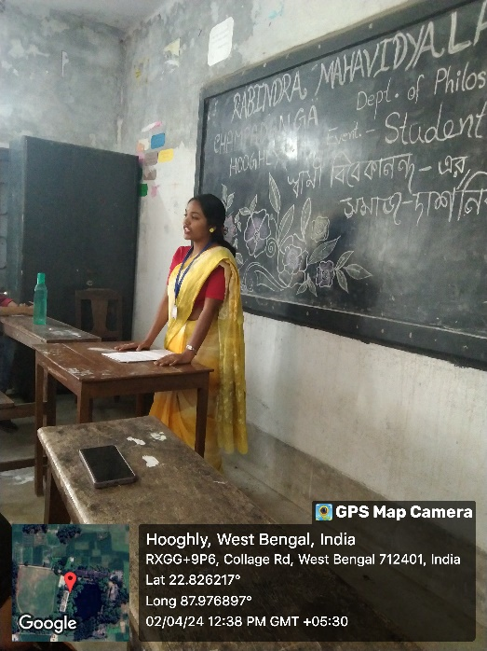
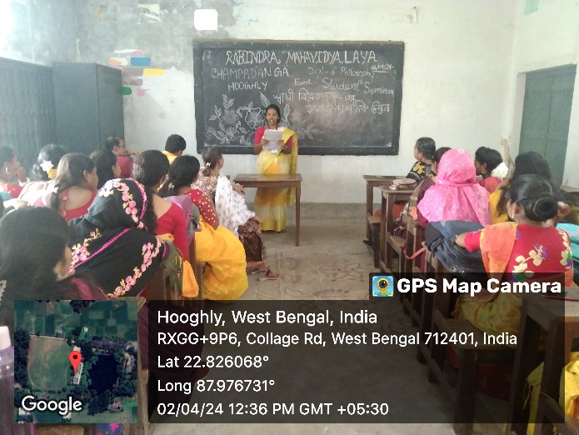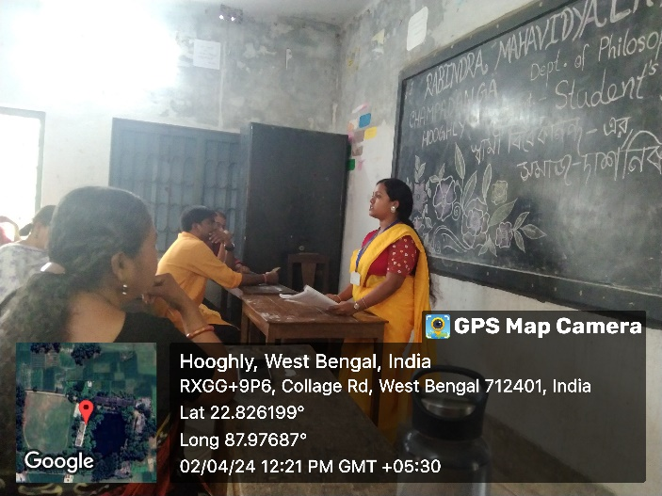
Paper presented by students

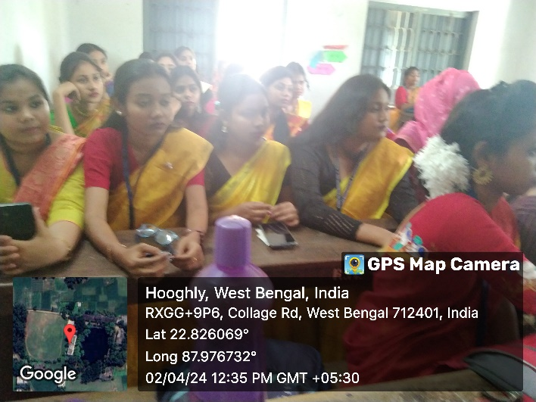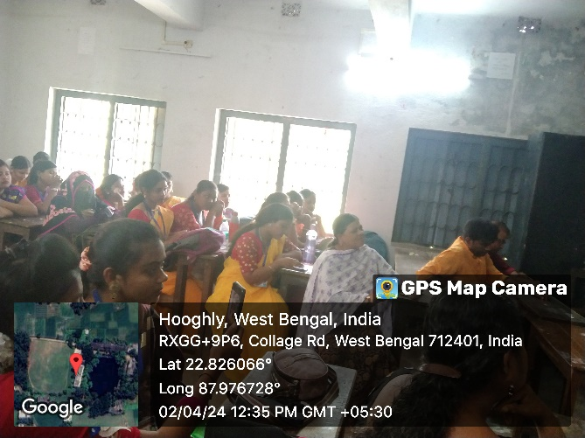

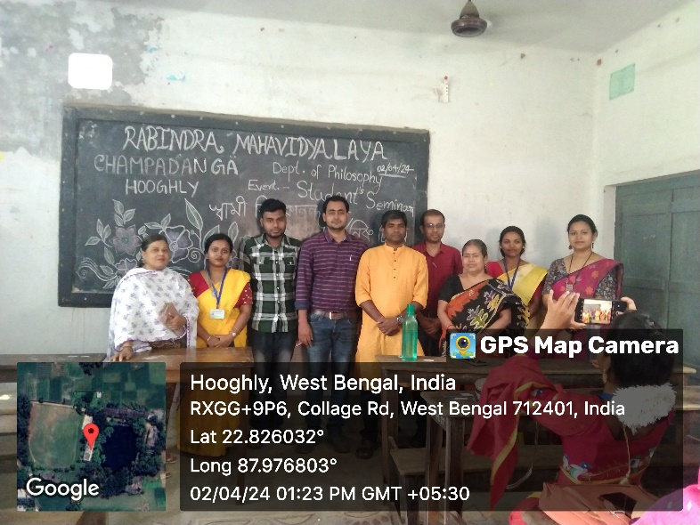

Feedback Summary
- 48 responses (80%) received.
- 82% felt satisfactory.
- 90% opined the event helped to improve their academic performance.
- 75% wished to occur the events more than once every year.

What have students learnt from the event?
- Presentation skills;
- Self-confidence;
- Critical thinking;

Suggestions
- More extra-curricular activities and healthy competition;
- Special class for grooming;

